UI React Final Project – Team Documentation Template

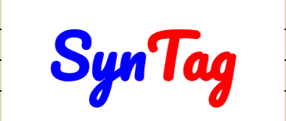-Project Information

## Project Name: Najahi – نجاحي

## Project Category:

☐ E-Commerce

☐ Dashboard

☐ Social App

☐ Mobile-Responsive Website

☐ Productivity Tool

**✅** Other: Education

## Team Members

|  |  |  |  |
| --- | --- | --- | --- |
| **Student Name** | **Role** | **Tasks** | **ID** |
| Ahmad Essawii | Leader | 1. Make Repository 2. Merging Code on GitHub 3. Handling Two Screens | 12429664 |
| Leen Arafat | Developer | 1. Handling Two Screens 2. Modify README.md File | 12428865 |
| Yaqeen Ashour | Developer | 1. Handling Two Screens 2. Print Team Documentation | 12429716 |
| Jawad Shaheen | Developer | 1. Handling Two Screens | 12400460 |

## **Project Description:**

**"Najahi"** is an advanced, integrated digital educational platform, specifically designed for secondary school students in Palestine (Grades 10, 11, 12). The platform aims to empower students and help them achieve academic excellence by providing all educational resources and support services in one place, bridging the gap between the student and the curriculum, and between the student and the educational community.

**Comprehensive Digital Library**: Contains educational materials organized by grade and track (Scientific, Literary, Industrial) including e-books, summaries, past exams, and educational videos.

"Material Donation" System: A unique feature aimed at building a cooperative community, where students can donate their used books and notebooks to their peers, promoting a culture of sharing and solidarity and reducing the financial burden.

Palestinian Universities Directory: Provides a brief description about the most important local universities and features, to help Tawjihi students plan their university future.

Interactive Study Groups: Connects students with their peers through groups on Facebook, WhatsApp, Telegram, and Discord -for group study, experience exchange, and homework assistance.

"Nearby Teachers" Network: A directory that connects students with qualified teachers in their areas for private lessons or academic guidance, with details about their specializations and ratings.

"Najahi" is not just a website, but a "national educational project" that seeks to empower the future generation of Palestinians through simple and effective technology, a supportive community, and focused educational resources, to be the companion of every ambitious student on their journey towards achieving their university and professional dream.

**Screen List**

### **Screen #1 (Login Page)**

**Assigned To:** ________________________________________________________________  
 **Purpose of Screen:** Make an account – or continute as a Guest  
 **Screen Components:** ________________________________________________________________________________________________________________________________________________________

**User Flow:**________________________________________________________________________________________________________________________________________________________

**State Management:** ☐ useState  
 ☐ useEffect  
 ☐ userRef  
 ☐ No State

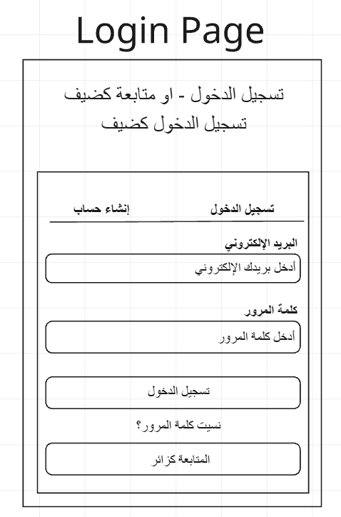**Wireframes:**

**Screen List**

### **Screen #2 (Main Page)**

**Assigned To:** ________________________________________________________________  
 **Purpose of Screen:** Make an account – or continute as a Guest  
 **Screen Components:** ________________________________________________________________________________________________________________________________________________________

**User Flow:**________________________________________________________________________________________________________________________________________________________

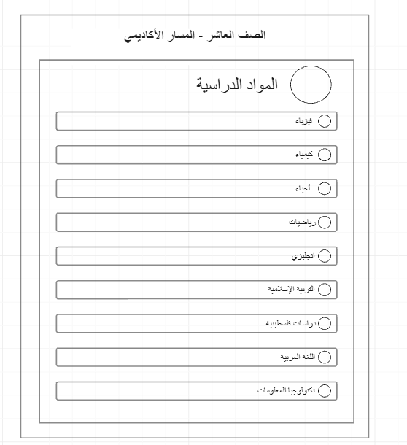**State Management:** ☐ useState  
 ☐ useEffect  
 ☐ userRef  
 ☐ No State

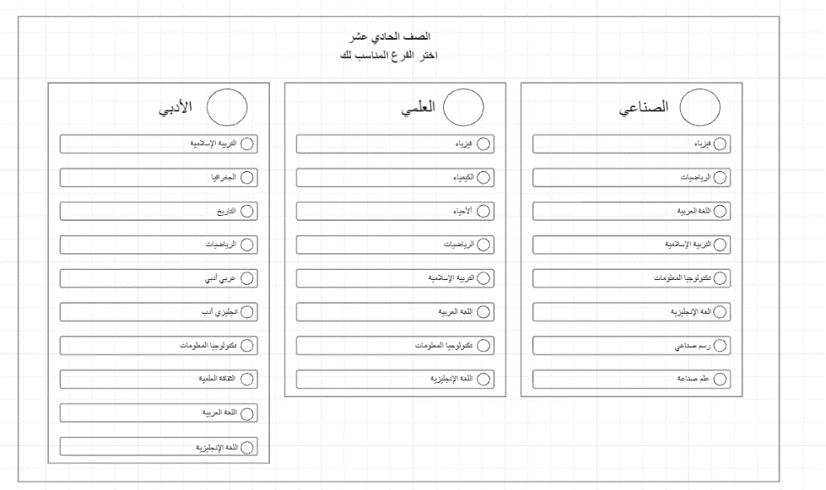**Wireframes:**

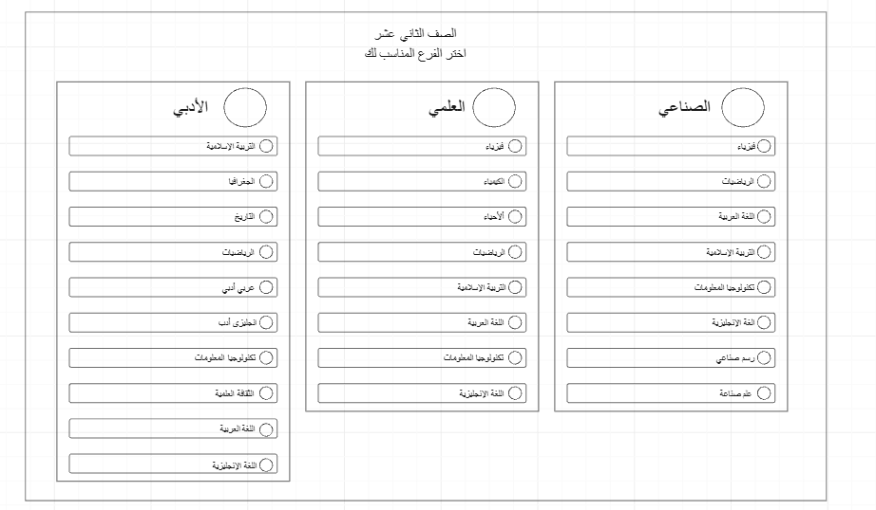

### **Screen #3 (About Us)**

**Assigned To:** ________________________________________________________________  
 **Purpose of Screen:** Make an account – or continute as a Guest  
 **Screen Components:** ________________________________________________________________________________________________________________________________________________________

**User Flow:**________________________________________________________________________________________________________________________________________________________

**State Management:** ☐ useState  
 ☐ useEffect  
 ☐ userRef  
 ☐ No State

**Wireframes:**

### 

### **Screen #4 (**Donatioan**)**

**Assigned To:** ________________________________________________________________  
 **Purpose of Screen:** Make an account – or continute as a Guest  
 **Screen Components:** ________________________________________________________________________________________________________________________________________________________

**User Flow:**________________________________________________________________________________________________________________________________________________________

**State Management:** ☐ useState  
 ☐ useEffect  
 ☐ userRef  
 ☐ No State

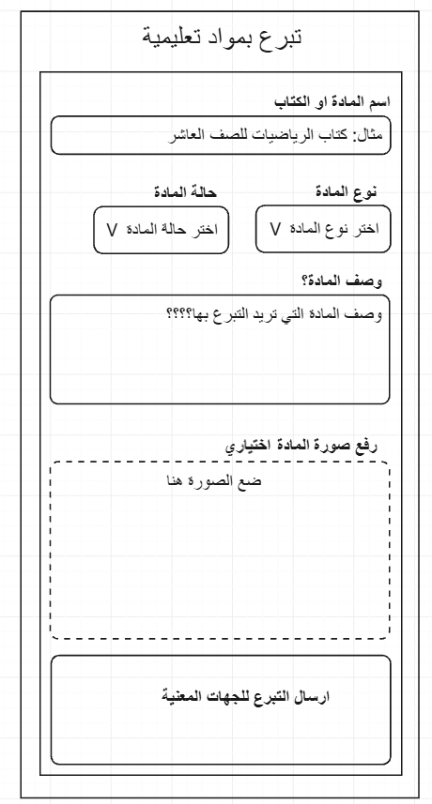**Wireframes:**

### **Screen #5 (**Find Materials**)**

**Assigned To:** ________________________________________________________________  
 **Purpose of Screen:** Make an account – or continute as a Guest  
 **Screen Components:** ________________________________________________________________________________________________________________________________________________________

**User Flow:**________________________________________________________________________________________________________________________________________________________

**State Management:** ☐ useState  
 ☐ useEffect  
 ☐ userRef  
 ☐ No State

**Wireframes:**

### 

### **Screen #6 (**Find University**)**

**Assigned To:** ________________________________________________________________  
 **Purpose of Screen:** Make an account – or continute as a Guest  
 **Screen Components:** ________________________________________________________________________________________________________________________________________________________

**User Flow:**________________________________________________________________________________________________________________________________________________________

**State Management:** ☐ useState  
 ☐ useEffect  
 ☐ userRef  
 ☐ No State

**Wireframes:**

### 

### **Screen #7 (**Learning Groups**)**

**Assigned To:** ________________________________________________________________  
 **Purpose of Screen:** Make an account – or continute as a Guest  
 **Screen Components:** ________________________________________________________________________________________________________________________________________________________

**User Flow:**________________________________________________________________________________________________________________________________________________________

**State Management:** ☐ useState  
 ☐ useEffect  
 ☐ userRef  
 ☐ No State

**Wireframes:**

### 

### **Screen #7 (**Find A Tutor**)**

**Assigned To:** ________________________________________________________________  
 **Purpose of Screen:** Make an account – or continute as a Guest  
 **Screen Components:** ________________________________________________________________________________________________________________________________________________________

**User Flow:**________________________________________________________________________________________________________________________________________________________

**State Management:** ☐ useState  
 ☐ useEffect  
 ☐ userRef  
 ☐ No State

**Wireframes:**

### 

Challenges & Notes

Final Deliverables

☑ GitHub Repo  
☑ Responsive UI  
☑ Minimum 8 screens (4 students × 2 screens)  
☑ Clean Code & Components  
☑ Presentation (5–8 min)